Bridgepoint Parts Catalog

Section XXVI: Fogger & Ozone Generator Parts Page 1

PBUR01

Barrel Assembly – Hot Fogger
Heating Element - AS42

PCUR01

Kit Carburetor Repair
Golden Eagle Fogger AS39

PCUR02

Kit Gas Filter
Golden Eagle Fogger AS39

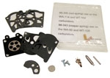
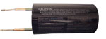
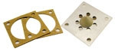

PBU1171

Strainer – Hot Fogger
Solution Pick-up - AS42

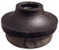

PBU1189

Spinner & Spring – Hot Fogger
AS42

PCUR03

Petal Valve
Golden Eagle Fogger AS39

PBU1160

O-ring Gasket - Hot Fogger
Container - AS42

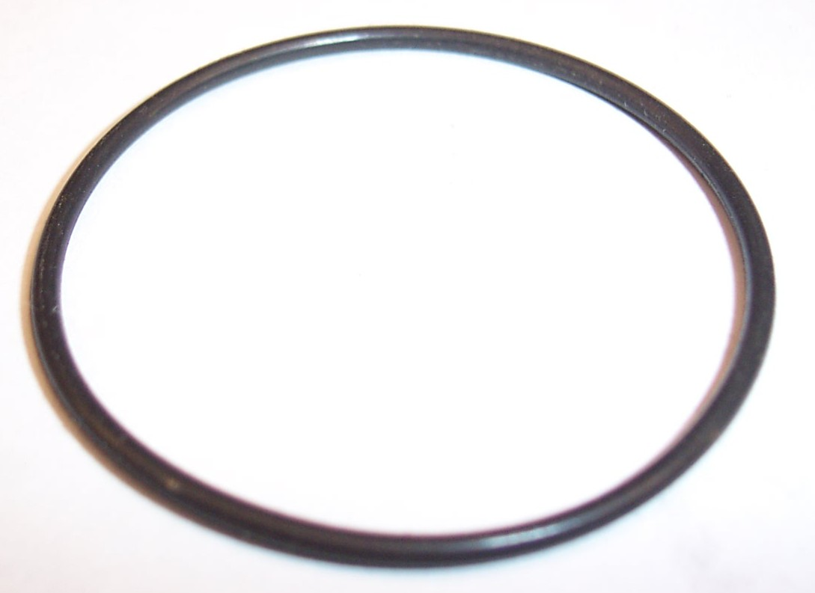

PCUR04

Carburetor
Golden Eagle Fogger AS39

PBU02011

Kit Pump Repair – Hot Fogger
AS42

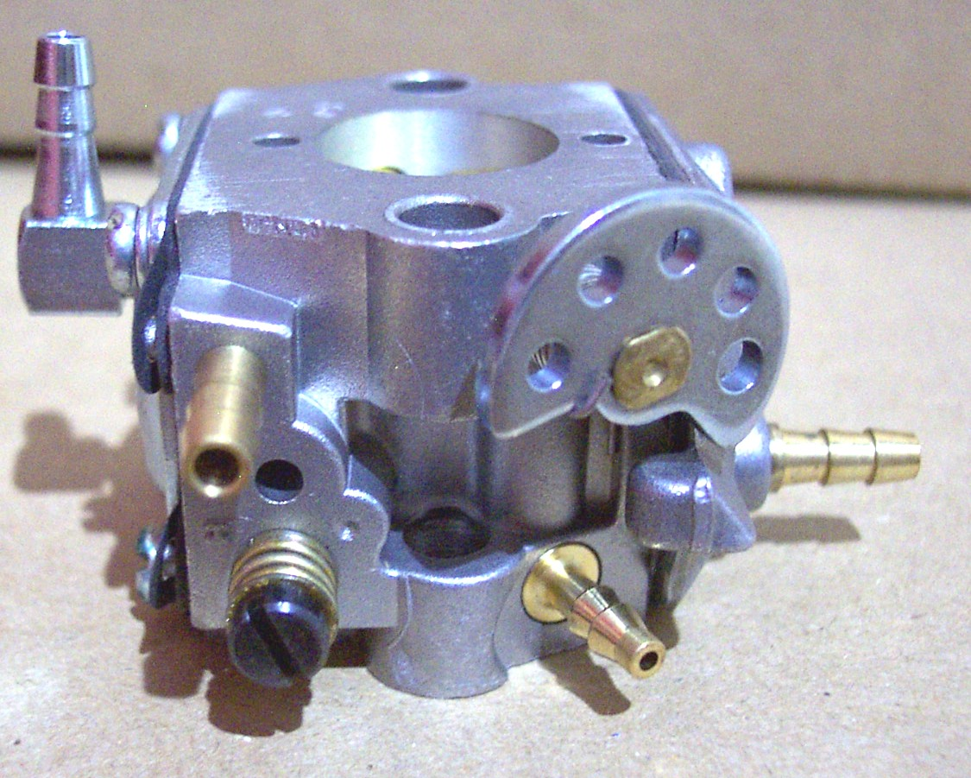
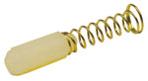
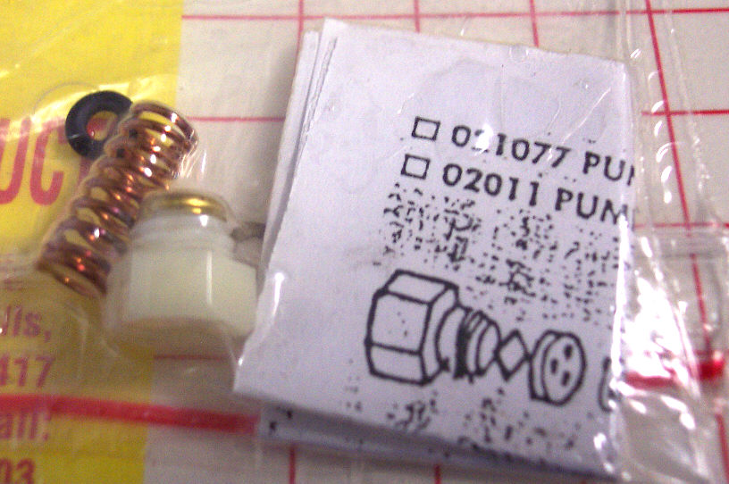

PCUR05

Gasket - Carburetor
Golden Eagle Fogger AS39

PBU1900

Spray Nozzle – Hot Fogger
AS42

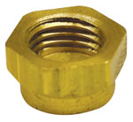

PCUR06

Remote Plug – 12VDC

Car Lighter Power Adapter
Golden Eagle Fogger AS39

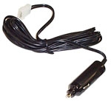

PBU1221

Tank Aluminum - Hot Fogger
Container - AS42

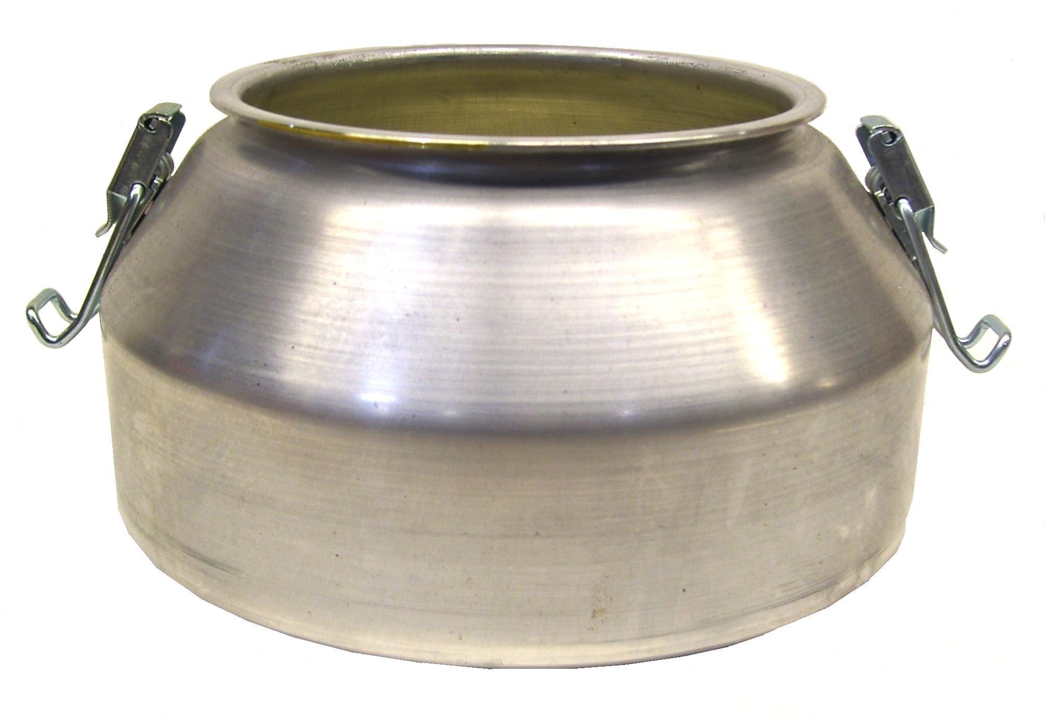

PCUR07

Ignition Coil
Golden Eagle Fogger AS39

PHO-T1

Transformer – Sonozaire

Ozone Generator

AS34 – Model 115A – Use 3/4amp fuse
AS35 – Model 330A – Use 1-1/4amp fuse

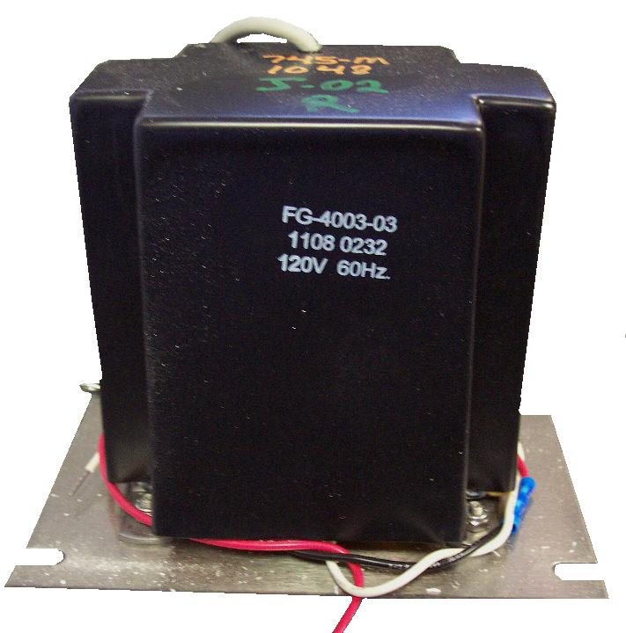

AV08

Vac Motor 5.7” 2 Stage
Pure Mist Fogger AS40

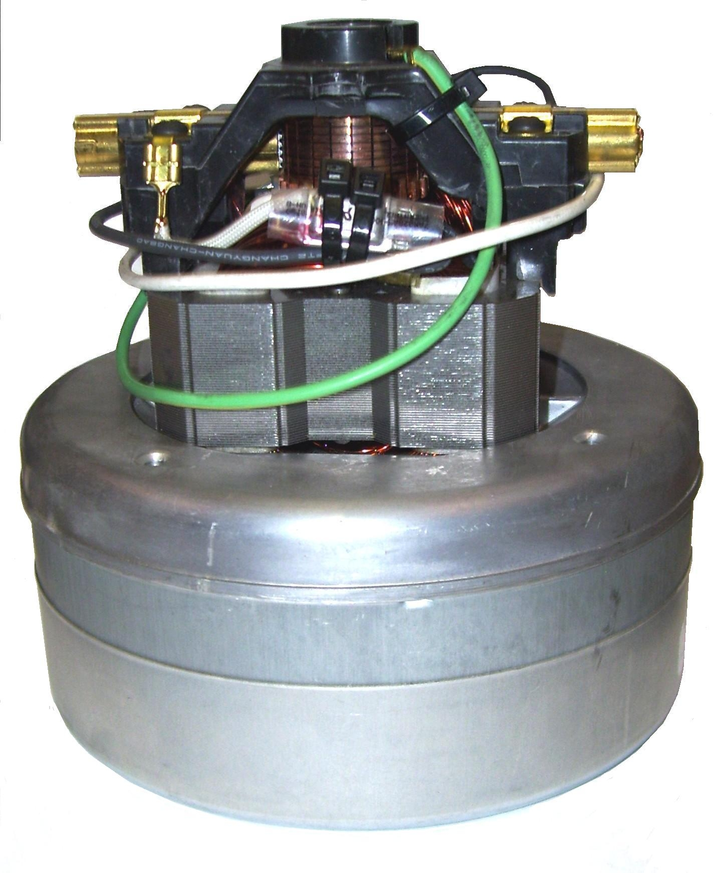

PHO1007-19-2

Tube Glass Insulator

Sonozaire Ozone Generator
AS34 – Model 115A
AS35 – Model 330A (Qty. 3)

PHO-VT1

Rheostat – Level Control

Sonozaire Ozone Generator

AS34 – Model 115A
AS35 – Model 330A

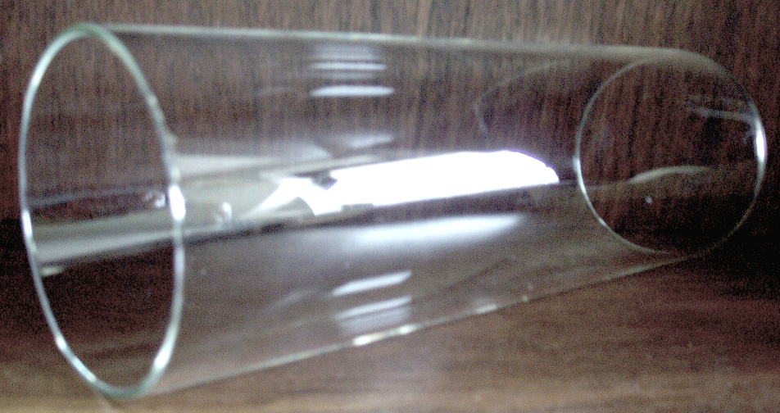

PHO-S2

Switch - Selector

Sonozaire Ozone Generator

AS34 – Model 115A
AS35 – Model 330A

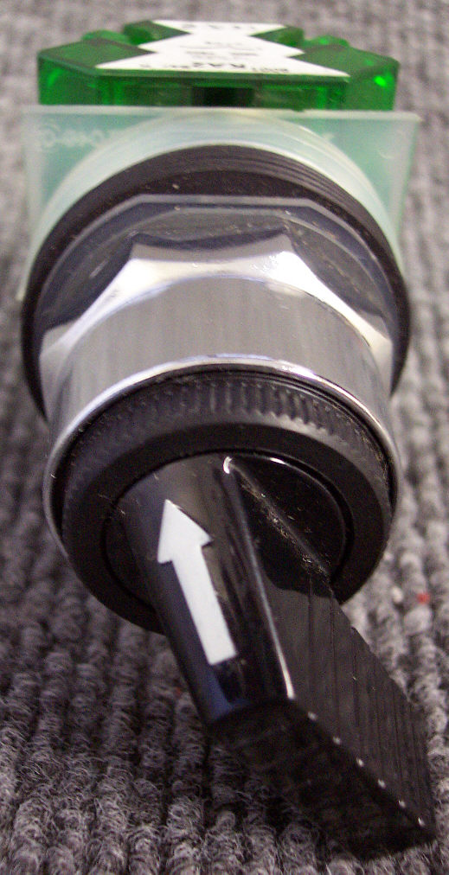

PHO-TIMER

Timer – 12 Hour

Sonozaire Ozone Generator
AS35 – Model 330A
